(12 pt)
(12 pt)
(12 pt)
TITLE OF THE PAPER (14 pt)
(12 pt)
(12 pt)
First Author¹, Second Author² and Others³ (12 pt)
(12 pt)
¹Affiliation 1; emaiil@email.com
² Affiliation 2; email@email.com (11 pt)
*Correspondence: email@email.com; tel.: (optional) (11 pt)
(12 pt)
Margin 2,5 cm wide
(12 pt)
ABSTRACT (12 pt)
(12 pt)
Please start with an Abstract of up to 200 words. The Abstract should state the principal objectives and the scope of the investigation, as well as the methodology, employed. It should summarize the results and state the principal conclusions. The word ABSTRACT, in Capitals, should appear as a title, as seen above.
(12 pt)
Keywords: List the keywords covered in your paper (between four and six). (12 pt)
(12 pt)
(12 pt)
Margin 2,0 cm wide
- Introduction (12 pt, aligned left 0 cm, hanging at 0,8 cm)
(12 pt)
All manuscripts should be in English in MS-Word® format. The expected number of pages of the conference paper is between 6 and 10 pages. Use only normal style Times New Roman 12 pt. Use italic for emphasizing a word or phrase. Do not use boldface typing except for section headings. When referring to bibliographical references in the text, place the reference number in square brackets [1, 2].
When receiving the manuscript, we assume that the corresponding authors grant us the copyrights to use the manuscripts for the publishing in conference proceedings.
Program of the conference will be available on https://ewgae2022.si/programme/. The estimated time for the keynote lecture is 30 minutes, followed by 5 minutes of discussion. The estimated time for the oral presentation is 15-20 minutes, followed by 5 minutes of discussion.
When sending the manuscript in Word format to ewgae2022@fs.uni-lj.si please specify/choose the session that best describes your work:
Special sessions
- Students in action (Student Paper Award)
- Companies in Action
- AE Standardization
- Projects in Action

Regular sessions
- Advanced composites
- Monitoring metallic structures
- Civil engineering
Margin 2,0 cm high
- Process monitoring
- Signal processing
- Material characterization
- Corrosion
- Pressure vessels
- other
(12 pt)
(12 pt)
2. Chapter
(12 pt)
2.1 Sub chapter (12 pt, aligned left 0 cm, hanging at 0,8 cm)
Headings should be in boldface, subheadings should be in boldface italic
- main headings should be numbered,
- subheadings should carry the number of the main heading followed by a number indicating a sub heading number...

3. Figure sample

Place figure to the center of the page. Center figure caption below the figure. Refer to figures as Fig. 1 in the text and number them consecutively.
(12 pt)
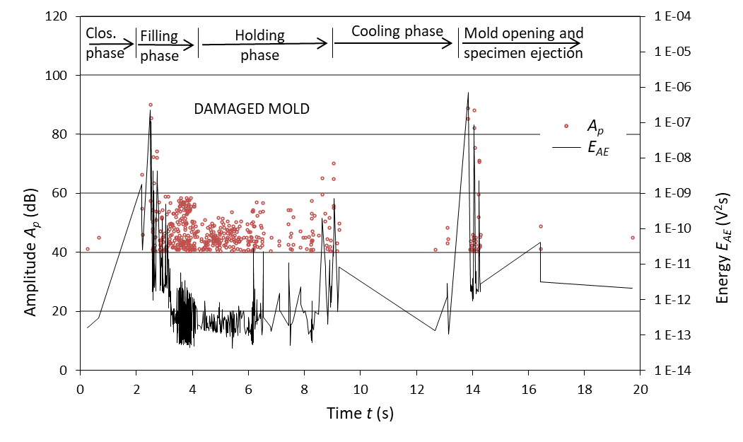
(12 pt)
Fig. 1: AE hits during injection molding with a damaged mold.(12 pt)

4. Table sample

Place table to the center of the page. Center table caption above the table. Refer to tables as Table 1, Table 2, … in the text and number them consecutively. The SI system of units for nomenclature, symbols, and abbreviations should be followed closely. Symbols for physical quantities in the text should be written in italics. Symbols for units that consist of letters should be in plain text (e.g., K, min, mm, etc.) and added in parentheses e.g. t (s).
Abbreviations should be spelt out in full on the first appearance followed by the abbreviation in parentheses, e.g. variable time geometry (VTG).

Table 1: Characteristics of the integrated ferrite core. (12 pt)
(12 pt)
PARAMETER | MEASURING CONDITIONS | VALUE
μ_{i} ( ) | 10 kHz, 25 °C, 0.1 mT | 10,000 ± 20%
η_{B} (10⁻³/T) | 10 kHz, 25 °C, 1.5 – 3.0 mT | < 1.4
B_{S} (mT) | 10 kHz, 25 °C, 250 A/m | ≥ 390
ρ (Ωm) | DC, 25 °C | = 0.1
T_{C} (°C) |  | ≥ 130
ρ_{S} (kg/m³) |  | = 4900

5. Equations

Place equation to the center of the page. When numbering equations, enclose numbers in parentheses and justify with right margin of the page. Define any acronyms used in equations.

<Equation> (1)

6. Conclusions

Following the foregoing guidelines, you will enable us easier preparing of conference proceedings.
Send your manuscript by e-mail to ewgae2022@fs.uni-lj.si, please indicate corresponding author.

7. References

- Hackenschmidt, R., Alber-Laukant, B., Rieg, F. (2010). Simulating nonlinear materials under centrifugal forces by using intelligent cross-linked simulations. Strojniški vestnik – Journal of Mechanical Engineering, vol. 57, no. 7-8, p. 531-538, doi:10.5545/sv-jme.2011.013. (for journal paper)
- Sause, M.G.R., Jasiūnienė, E. (2021). Structural health honitoring damage detection systems for aerospace. Springer Nature, Cham, doi: 10.1007/978-3-030-72192-3. (for books)
- Aggelis, D.G., Sause, M.G.R., Packo, P., Pullin, R., Grigg, S., Kek, T., Lai, Y.K. (2021). Acoustic emission: Chapter 7. Sause, M.G.R., Jasiūnienė, E. (Eds.), Structural health monitoring damage detection systems for aerospace. Springer Nature, Cham, p. 175-217, doi: 10.1007%2F978-3-030-72192-3_7. (for chapter of the book)
- Bergant, Z., Janez, J., Grum, J. (2017). Ultrasonic C-scan testing of epoxy/glass fiber composite. Conference proceedings, The 14th International Conference of the Slovenian Society for Non-Destructive Testing, titled: Application of contemporary non-destructive testing in engineering, 4-6 September, St. Bernardin/Portorož, Slovenia, p. 41-48, doi code if possible. (Paper in proceedings)
↑
(aligned left 0 cm, hanging at 1 cm)

